Supplementary Appendix
Safety of Janus Kinase Inhibitors Compared With Vedolizumab or Ustekinumab in Older Adults With Ulcerative Colitis
Supplementary Methods
Adults aged 60 years or older with ulcerative colitis in the TriNetX US Collaborative Network were assigned to the JAK inhibitor group at the first qualifying record for tofacitinib or upadacitinib and to the comparator group at the first qualifying record for vedolizumab or ustekinumab. The index date was the qualifying treatment record. The primary analysis required no recorded advanced inflammatory bowel disease therapy during the 365 days before index. Patients with recent serious infection, HIV, prior solid organ transplant, or competing advanced therapy around index were excluded.
Propensity scores were estimated and matched within TriNetX using 33 prespecified covariates. Covariates included demographics, inflammatory bowel disease phenotype terms, prior steroid and immunomodulator exposure, prior infections, cardiovascular and thrombotic comorbidities, metabolic and nutritional comorbidities, healthcare utilization, body mass index, albumin, hemoglobin, and creatinine. Balance was assessed using standardized mean differences, with values below 0.10 considered acceptable.
Primary outcomes were assessed from days 1 through 365 after treatment initiation. Sensitivity analyses evaluated a no-washout design and cumulative two-year follow-up from days 1 through 730. Hazard ratios with 95% confidence intervals were estimated using Cox models. TriNetX-suppressed cells were not reverse engineered.
Abbreviations: CI, confidence interval; EHR, electronic health record; HR, hazard ratio; IBD, inflammatory bowel disease; JAK, Janus kinase; MACE, major adverse cardiovascular events; SMD, standardized mean difference; UC, ulcerative colitis; VTE, venous thromboembolism.
Supplementary Table S1. Cohort, exposure, and follow-up definitions
Domain | Definition
Data source | TriNetX US Collaborative Network de-identified electronic health record data.
Population | Adults aged 60 years or older with ulcerative colitis recorded before treatment initiation.
Exposure | First qualifying record for tofacitinib or upadacitinib after eligibility criteria were met.
Comparator | First qualifying record for vedolizumab or ustekinumab after eligibility criteria were met.
Index date | Date of the first qualifying exposure or comparator treatment record.
Primary washout | No recorded advanced inflammatory bowel disease therapy in the 365 days before index.
Primary exclusions | Recent serious infection, HIV, prior solid organ transplant, or competing advanced therapy around index.
Follow-up | Initiation-based follow-up from day 1 after index through the specified window; patients were not censored for later switching or discontinuation in exported analyses.
No-washout sensitivity analysis | Same age, disease, exposure, and comparator definitions, without the 365-day advanced-therapy washout.
Two-year sensitivity analysis | Same primary cohort and matching framework, with cumulative outcome ascertainment from days 1 through 730.

Supplementary Table S2. Outcome definitions
Outcome | Type | Definition
Infection composite | Primary safety outcome | Composite of infection diagnosis concepts used in the TriNetX outcome panel.
Herpes zoster | Safety outcome | Herpes zoster diagnosis concepts; reported only when cell-size rules permitted and suppressed in the primary matched analysis.
MACE | Primary safety outcome | Coded major adverse cardiovascular event diagnosis proxy.
VTE | Primary safety outcome | Coded venous thromboembolism diagnosis proxy.
Inpatient encounter | Safety/utilization outcome | Recorded inpatient encounter after treatment initiation.
IV steroid administration or colectomy | Supportive disease-control outcome | Recorded intravenous steroid administration or colectomy/proctocolectomy.
Cataract | Negative control outcome | Cataract diagnosis outcome, used as a falsification check when reportable.
Knee osteoarthritis | Negative control outcome | Knee osteoarthritis diagnosis outcome, used as a falsification check when reportable.

Supplementary Table S3. Matching and statistical notes
Item | Description
Matching method | TriNetX 1:1 propensity-score matching after cohort construction.
Covariate set | The same 33 covariates were used in the primary, no-washout, and two-year analyses.
Covariate domains | Demographics, inflammatory bowel disease phenotype, medications, prior infections, cardiometabolic and thrombotic comorbidities, healthcare utilization, body mass index, albumin, hemoglobin, and creatinine.
Balance assessment | Standardized mean differences were exported from TriNetX; post-match values below 0.10 were considered balanced.
Missing data | No external imputation was performed. Laboratory covariates were based on recorded electronic health record values and platform handling of recorded data.
Effect estimate | Cox hazard ratios with 95% confidence intervals were used as the primary time-to-event summaries.
Proportional-hazards diagnostics | Exported proportional-hazards test P values were reviewed; estimates with significant tests were interpreted as fixed-window descriptive summaries.
Suppressed cells | TriNetX-suppressed cells were left suppressed and were not reverse engineered.

Supplementary Table S4. Baseline balance after matching
Covariate | Category | JAK after matching | Comparator after matching | SMD after
Age at index | Demographics | 66.30 (7.50) | 66.39 (8.05) | 0.011
Male | Demographics | 432 (49.3%) | 443 (50.6%) | 0.025
Black or African American | Demographics | 52 (5.9%) | 42 (4.8%) | 0.051
Hispanic or Latino | Demographics | 26 (3.0%) | 30 (3.4%) | 0.026
Crohn disease/regional enteritis | Diagnosis | 10 (1.1%) | 10 (1.1%) | 0.000
Ulcerative colitis | Diagnosis | 790 (90.2%) | 780 (89.0%) | 0.037
Indeterminate colitis | Diagnosis | 18 (2.1%) | 14 (1.6%) | 0.034
Glucocorticoids | Medication | 608 (69.4%) | 602 (68.7%) | 0.015
Azathioprine | Medication | 68 (7.8%) | 70 (8.0%) | 0.008
Mercaptopurine | Medication | 53 (6.1%) | 54 (6.2%) | 0.005
Methotrexate | Medication | 95 (10.8%) | 96 (11.0%) | 0.004
Enterocolitis due to Clostridium difficile | Diagnosis | 44 (5.0%) | 32 (3.7%) | 0.067
Pneumonia, unspecified organism | Diagnosis | 59 (6.7%) | 58 (6.6%) | 0.005
Herpes zoster | Diagnosis | 35 (4.0%) | 32 (3.7%) | 0.018
Other chronic obstructive pulmonary disease | Diagnosis | 69 (7.9%) | 73 (8.3%) | 0.017
Chronic kidney disease (CKD) | Diagnosis | 61 (7.0%) | 50 (5.7%) | 0.052
Heart failure | Diagnosis | 49 (5.6%) | 38 (4.3%) | 0.058
Chronic ischemic heart disease | Diagnosis | 132 (15.1%) | 121 (13.8%) | 0.036
Cerebral infarction | Diagnosis | 20 (2.3%) | 18 (2.1%) | 0.016
Other venous embolism/thrombosis | Diagnosis | 39 (4.5%) | 34 (3.9%) | 0.029
Lipid metabolism disorder/other hyperlipidemia | Diagnosis | 405 (46.2%) | 396 (45.2%) | 0.021
Type 2 diabetes mellitus | Diagnosis | 155 (17.7%) | 162 (18.5%) | 0.021
Overweight and obesity | Diagnosis | 179 (20.4%) | 175 (20.0%) | 0.011
Unspecified protein-calorie malnutrition | Diagnosis | 14 (1.6%) | 10 (1.1%) | 0.039
Nicotine dependence | Diagnosis | 69 (7.9%) | 76 (8.7%) | 0.029
Alcohol related disorders | Diagnosis | 33 (3.8%) | 30 (3.4%) | 0.018
Prior inpatient encounter | Visit | 331 (37.8%) | 291 (33.2%) | 0.096
Prior emergency department services | Procedure | 228 (26.0%) | 212 (24.2%) | 0.042
BMI | Clinical/laboratory | 28.72 (6.34) | 28.49 (5.63) | 0.038
Albumin, serum/plasma/blood | Clinical/laboratory | 3.94 (0.56) | 3.92 (0.56) | 0.029
Hemoglobin, blood | Clinical/laboratory | 12.71 (2.01) | 12.89 (1.92) | 0.096
Creatinine, serum/plasma/blood | Clinical/laboratory | 1.04 (3.69) | 0.90 (0.31) | 0.054
Asian | Demographics | 21 (2.4%) | 17 (1.9%) | 0.031
Values are shown as n (%) or mean (SD). JAK = Janus kinase; SMD = standardized mean difference.

Supplementary Table S5. Negative-control outcomes
Analysis | Outcome | JAK n/N | Comparator n/N | HR (95% CI) | P value
Primary | Cataract | Suppressed | Suppressed | Suppressed
Primary | Knee osteoarthritis | 45/876 | 38/876 | 1.32 (0.86-2.03) | 0.209
Days 1-730 | Cataract | 33/876 | 38/876 | 0.98 (0.62-1.57) | 0.938
Days 1-730 | Knee osteoarthritis | 64/876 | 58/876 | 1.27 (0.89-1.81) | 0.193
No washout | Cataract | 38/1329 | 51/1329 | 0.79 (0.52-1.20) | 0.264
No washout | Knee osteoarthritis | 81/1329 | 70/1329 | 1.24 (0.90-1.71) | 0.186
CI = confidence interval; HR = hazard ratio; JAK = Janus kinase.

Supplementary Table S6. STROBE checklist
STROBE section | Item | Location/description
Title/abstract | 1 | Title and abstract identify a retrospective cohort study using TriNetX.
Background/rationale | 2 | Introduction explains the clinical concern around JAK inhibitors in older ulcerative colitis.
Objectives | 3 | Objective states the comparison of JAK inhibitors with vedolizumab or ustekinumab in older ulcerative colitis.
Study design | 4 | Methods describe active-comparator cohort design and propensity-score matching.
Setting | 5 | Methods identify TriNetX US Collaborative Network.
Participants | 6 | Eligibility, exposure groups, washout, and exclusions are described.
Variables | 7 | Exposure, primary safety outcomes, supportive disease control outcome, and negative controls are defined.
Data sources/measurement | 8 | EHR-derived TriNetX diagnoses, medications, encounters, procedures, and laboratory values are stated.
Bias | 9 | Active comparator, washout, matching, sensitivity analyses, and negative controls are reported.
Study size | 10 | Initial and matched cohort sizes are reported.
Quantitative variables | 11 | Age and laboratory values are matched as TriNetX continuous covariates; categorical covariates are listed.
Statistical methods | 12 | Cox hazard ratios, 95% confidence intervals, log-rank P values, and PH checks are described.
Participants/results | 13 | Matched sample flow is shown in Figure 1.
Descriptive data | 14 | Baseline balance is reported in Table 1, Supplementary Table S4, and Supplementary Figure 2.
Outcome data | 15 | Primary and supportive disease control outcomes are reported in Table 2 and Figure 2; sensitivity analyses in Table 3 and Figure 3; negative controls in Supplementary Table S5 and Supplementary Figure 1; absolute risks in Supplementary Figure 3; Kaplan-Meier cumulative event curves in Supplementary Figure 4.
Main results | 16 | hazard ratios and confidence intervals are reported for all primary endpoints.
Other analyses | 17 | No-washout, two-year, and negative control analyses are reported.
Key results | 18 | Discussion summarizes the main safety finding.
Limitations | 19 | Discussion lists residual confounding, coding, exposure, pooling, and suppression limitations.
Interpretation | 20 | Discussion avoids causal overstatement and places findings in the literature.
Generalisability | 21 | Discussion limits interpretation to similar older ulcerative colitis patients represented in EHR data.
Funding | 22 | No external funding is stated.

Supplementary Figures
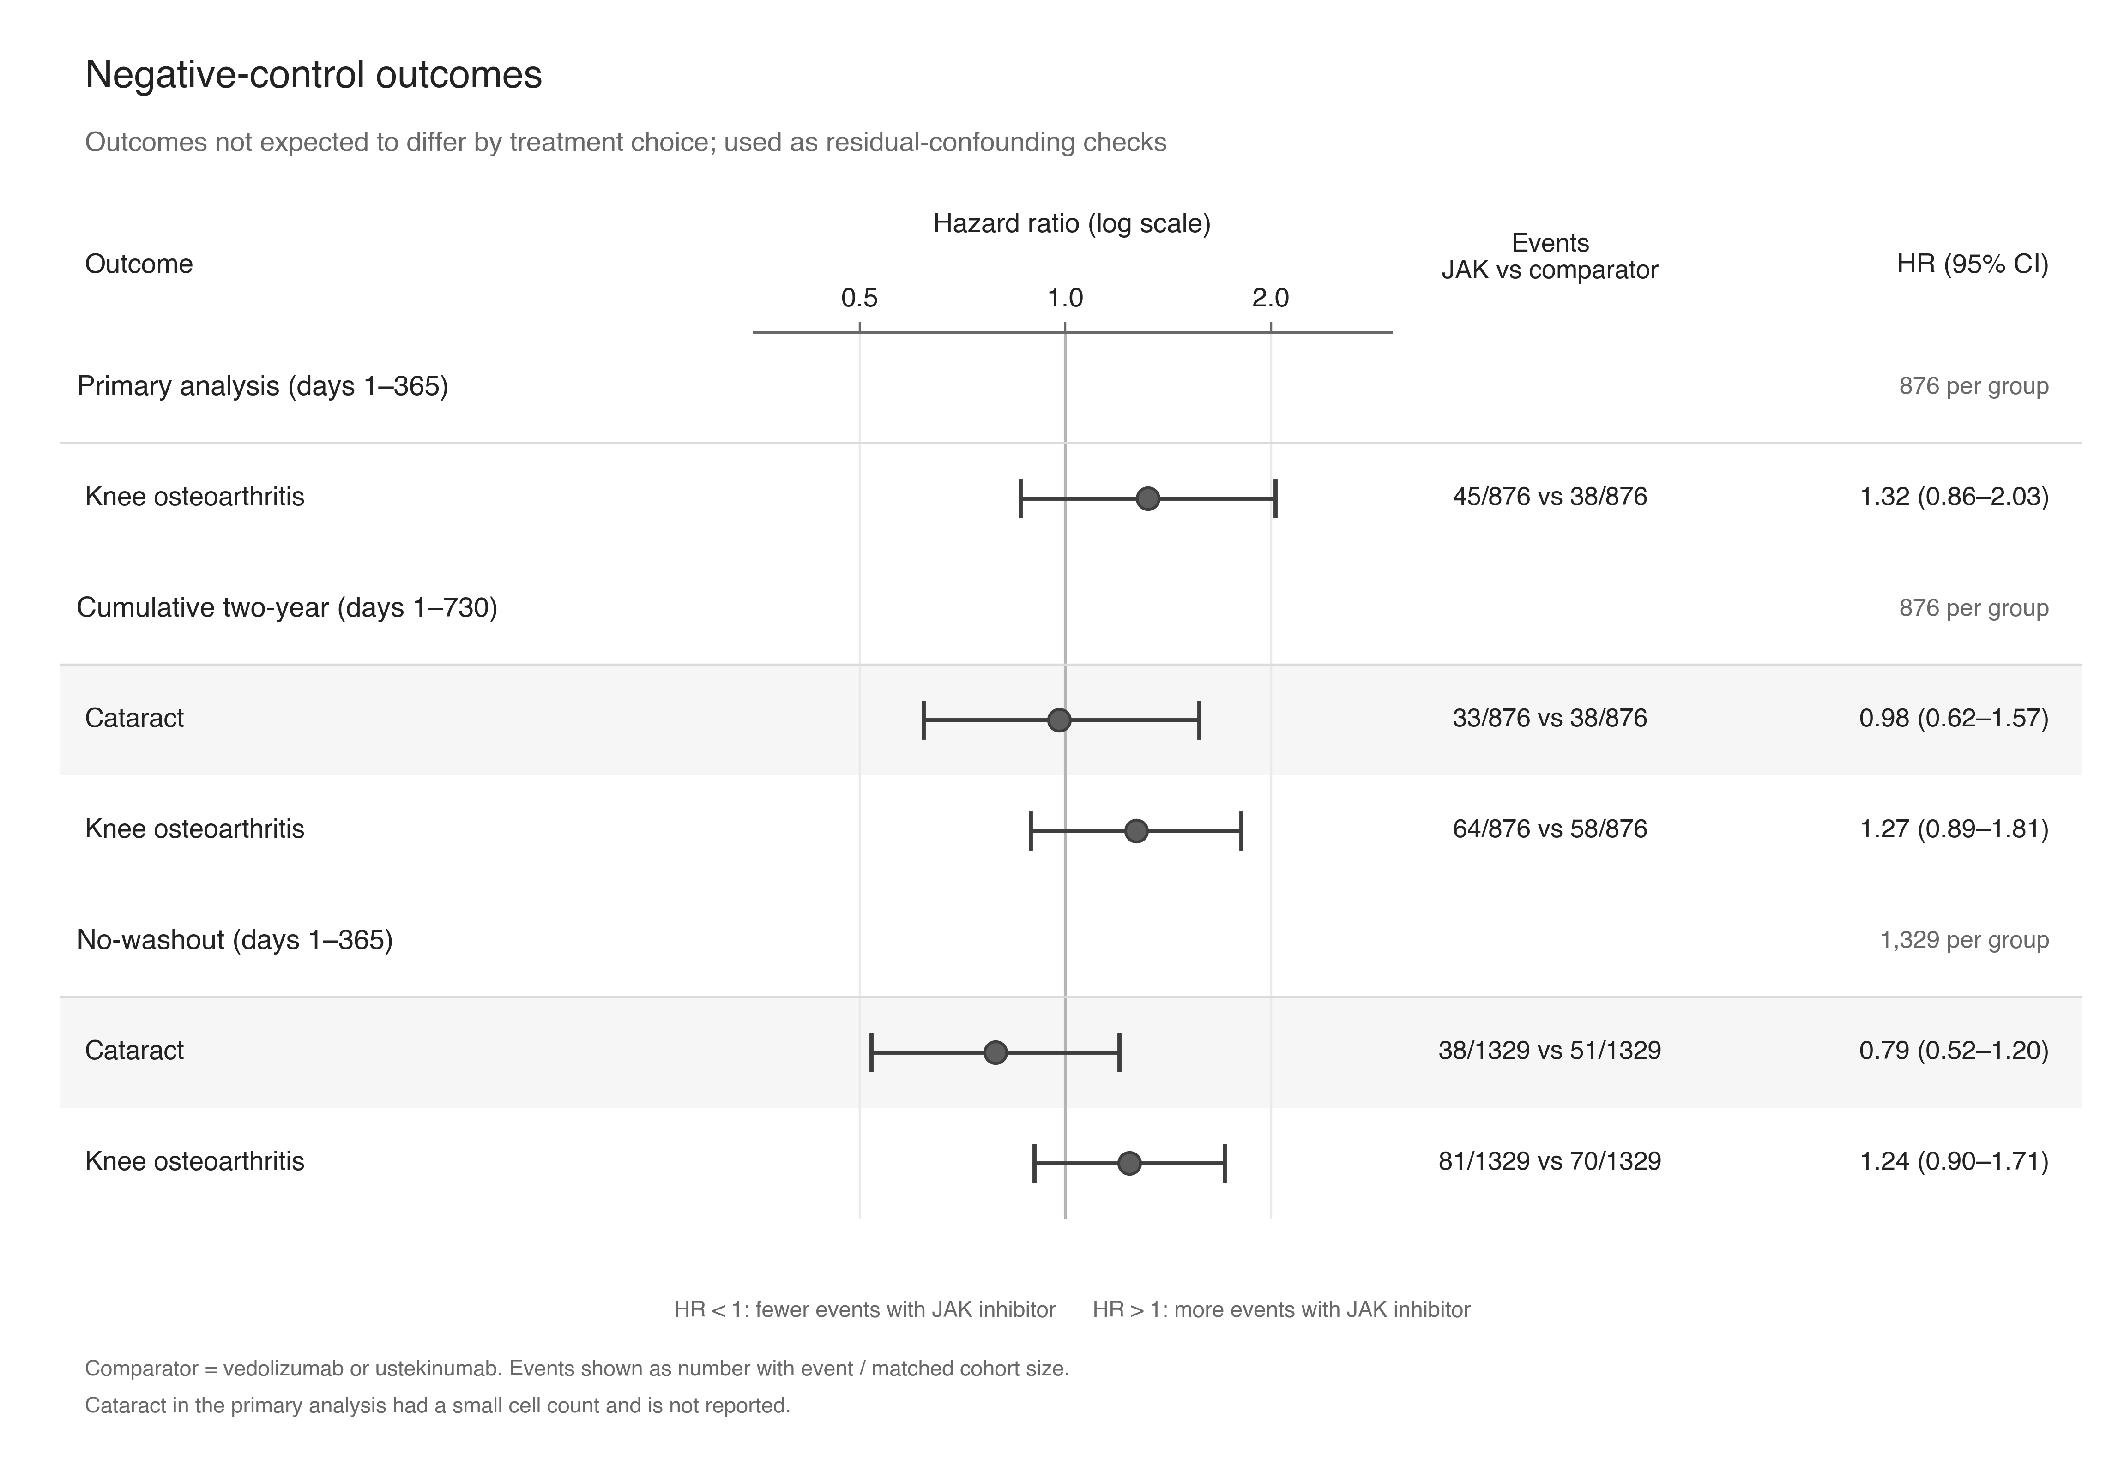
Supplementary Figure 1. Negative-control outcomes. Reportable negative-control outcomes across the primary, cumulative two-year, and no-washout analyses.

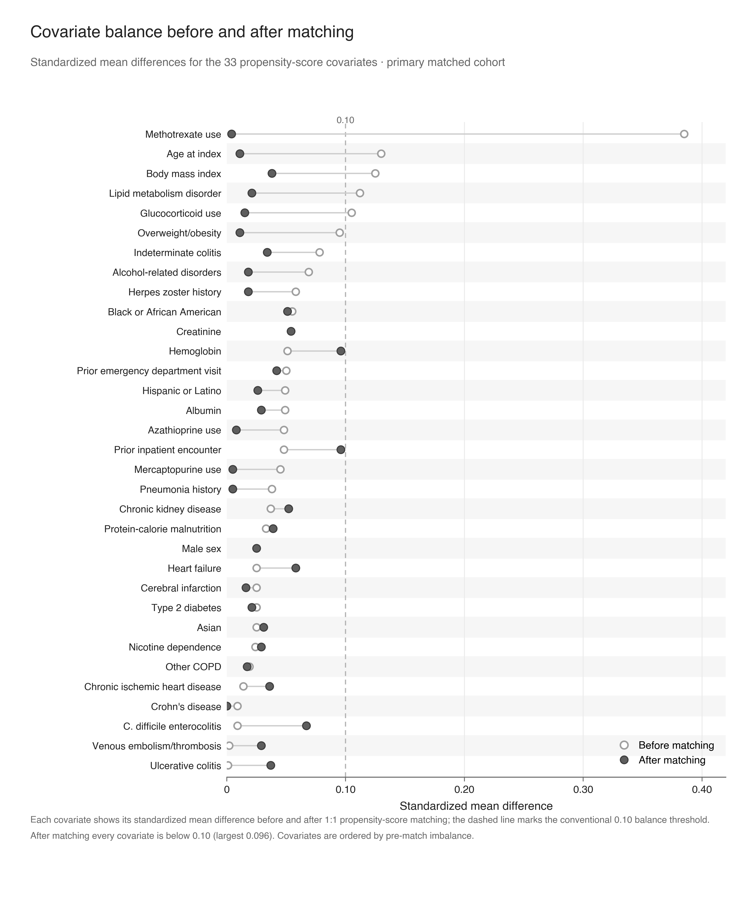
Supplementary Figure 2. Covariate balance. Standardized mean differences before and after propensity-score matching for the primary matched cohort.

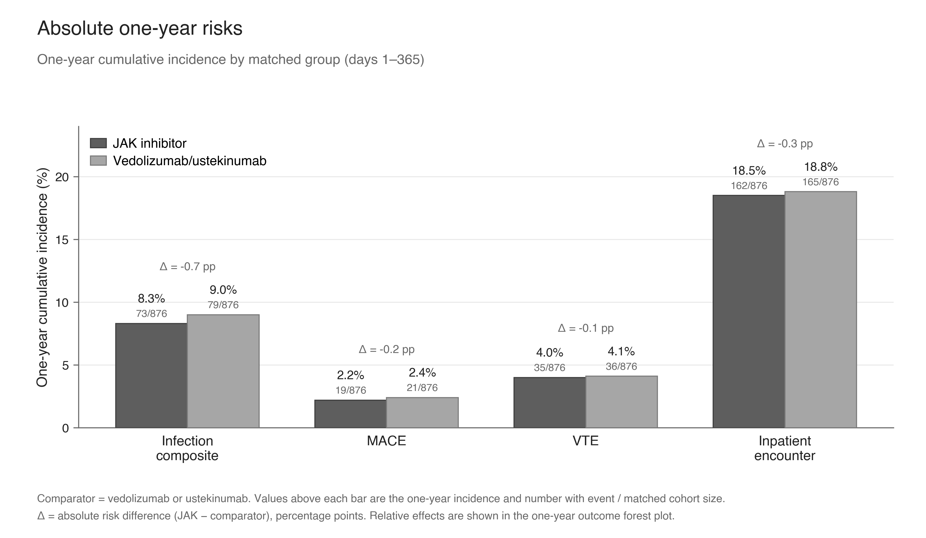
Supplementary Figure 3. Absolute one-year risks. One-year cumulative risks for primary safety outcomes by treatment group. JAK = Janus kinase.

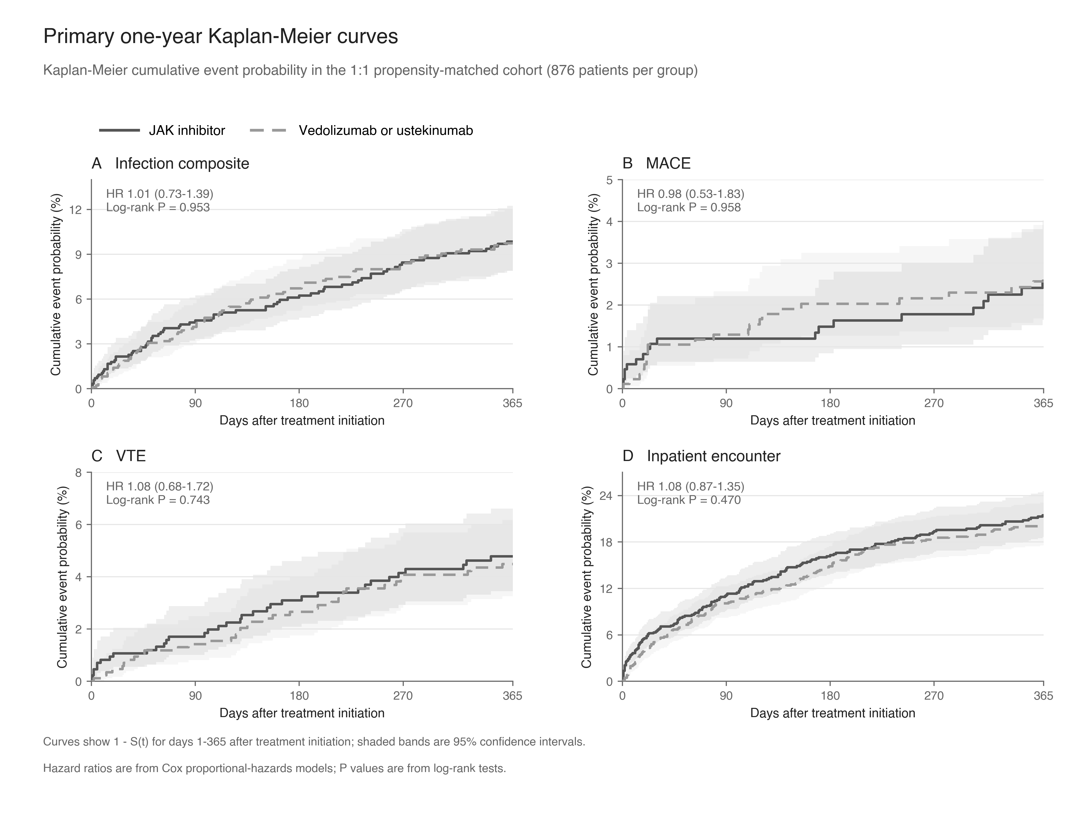
Supplementary Figure 4. Kaplan-Meier cumulative event curves. One-year cumulative event probability (1 - S(t)) for infection, major adverse cardiovascular events, venous thromboembolism, and inpatient encounter in the primary matched cohort. Solid dark-gray lines represent JAK inhibitor; dashed light-gray lines represent vedolizumab or ustekinumab. Shaded bands show 95% confidence intervals. JAK = Janus kinase.

